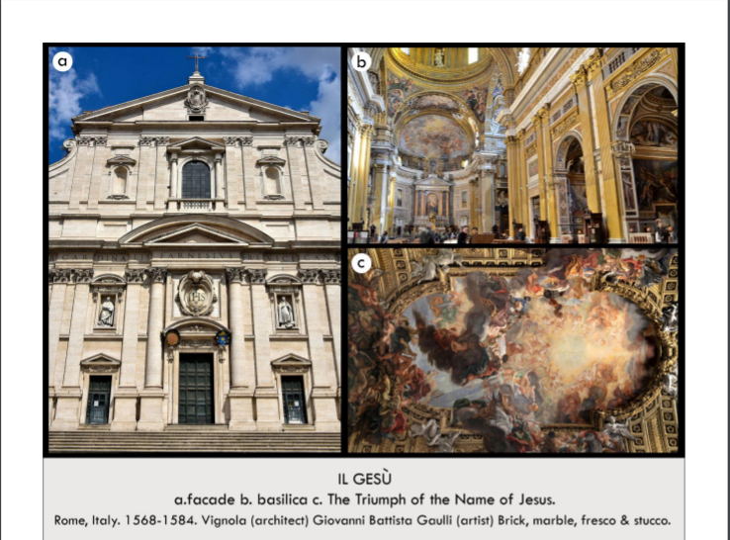

| **Form:** Has a baroque interior. A Gesú, which is simply Italian for the name for the mother church, Church was designed by Giacomo da Vignola and Giacomo Della Porta in 1575, Triumph of the Name of Jesus is a fresco painted in the traditional style, Ceiling fresco done in 1678-1679 by Giovanni Battista Gaulli  **Function:** Serves as the main and original church for the Jesuits- Important place for previous and current Jesuits, as it is the mother church, Also served as a model for the future Jesuit churches in terms of architecture and style. Ceiling fresco serves to illustrate the beliefs of the Jesuits, Called the people to their faith and scared them into not believing  **Content:** The columns are grouped and overlap= baroque, cornis is broken all the way across the front and there is text. There drama comes to the center, a porch to step onto, volutes going up the side, engaged columns. interior : gigantic large space with dome on top and chapels on the side, not renaissance, it is decorated in an opulent fashion, covered in gold, tromploy nature of painting on the ceiling. Single aisled church, removing others as a space for traffic to clear it up, Church has a cruciform floor plan, although the transept is not overly long on either side so it does not bear exactly like a cross in terms of proportions, The church has a dome over the intersection of the large nave and transept, Very dark interior, and it is thus chiefly dependent on natural lighting from outside, An interesting mix of the rational and Baroque styles, Focus on the altar in the center, Renaissance style columns= Corinthian, ornate, and made of rich materials, Some of them reuse ancient pieces, The reusing of ancient materials is called “spolia”. C) In the middle is the name of Jesus and making it into a symbol.  **Context:** During the mannerist period , pointing halfway between renaissance art and baroque periods of art. Created during the mid 1500s. Located in Rome, Italy. Central church of the Jesuits( people who go to new worlds and “education” of natives to become catholic). Saint Ignatius of Loyola, the founder of the newfound Jesuit religion, needed a church to serve as the religion’s center, They were very against the reformation and focused their teachings on charitable works, education, and missionaries, It was then funded by Cardinal Farnese, who was the Pope’s grandson, Church is in the center of old Rome Themes:Religion, spirituality, beliefs and values, War and social conflict, Power and authority, Social concerns/issues, God/religion C) Combination of architecture, sculpture and painting= everything is blending. ( which is very baroque)  **Compare:** Bernini’s Apse at Saint Peter’s Basilica, Michelangelo's Sistine Chapel  **82**  Early Europe & Colonial Americas |
| --- |

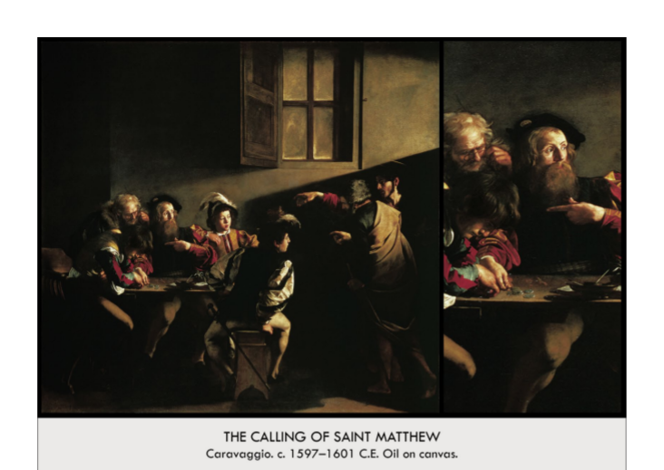

| **Form:** Shows drama, naturalism, light, sense of spice, and theatricality. Shows earthy and natural, something of this world. Painted by Caravaggio, Oil on canvas. located in the Contarelli chapel, San Luigi dei Francesci, Rome  **Function:** A religious commision by, put in a chapel. Didactic element (to portray the story of The Calling of Saint Matthew, taught from the Catholic perspective (recognizing Saints), so as to convince believers of the Catholic doctrines, to inspire support of the Counter-Reformation/Catholic Reformation) To bring viewer into the experience of the painting, Caravaggio does this by use of:commonplace setting contemporary clothing, realism, naturalism(rather than idealism of high renaissance) emotive, expressive theatrics. This also makes the "Catholic way" more accessible to people of all levels of education, of experience, of lifestyles  **Content:**, The image is seen in our space, and shows his beautiful use of space. Biblical story of the calling of Saint Matthew, Matthew, a tax collector is sitting at a table counting money, generally being shady, Jesus walks in from the right with Saint Peter by his side into a roman tavern, Jesus points to Matthew with his hand extended, says, "You. I want you" Jesus singles Matthew out and calls on him to join him and his disciples, Matthew points to himself in a gesture of incredulity. setting makes the event commonplace, relatable. Characters are all dressed in contemporary clothing, setting this event in Caravaggio's time, rather than biblical times. This serves to make Matthew's experience (sinner turned follower) into something that is relatable to and possible for the everyday citizen of Rome, closer to Caravaggio's own experiences. VERNACULAR  LIGHT, plays an active role in furthering the action/plot, rather than merely creating a general, ethereal glow as in the high renaissance, realistic, looks like it is streaming in from the open doorway behind Jesus and Peter, there is a clear light SOURCE, stream of sunlight comes in diagonally from top right corner, follow's Christ's finger pointing toward Matthew, highlights Matthew's face—almost seems an extension of Jesus's pointed finger. The artistic parallel between the work of Michelangelo and that of Caravaggio highlights Christ's status as "the redeemer" creates a full-circle/bookend effect  **Context:** Classic caravaggio story, used his friends and models of people he hired on the street, trule naturalism, he never drew . Caravaggio was a genius and he showed a true Baroque style of painting. Created during the beginning of the 17th century. Differs from mannerism and renaissance painting by bringing a striking naturalism and realism into religious paintings. Caravaggio really shows you what it's like to live during this time. The Counter-Reformation- The Catholic Church reacted against the Protestant Reformation begun by Martin Luther (1517), after a period of austerity and withdrawal from lavish art, Catholic church experienced a revival in Rome. Change of tactics:draw believers into the Catholic faith by enthralling drama, theatrics, and shocking beauty in artwork, architecture, want to make people feel an overpowering emotional response to Catholic-inspired art. differentiating their approach to Christianity from that of the Protestants. the Baroque style, frozen action (like movie stills), theatrical, high contrast chiaroscuro, diagonal lines, gruff, gritty realism (rather than idealized, perfect realism of high renaissance)  **Compare:**  **85**  Early Europe & Colonial Americas |
| --- |

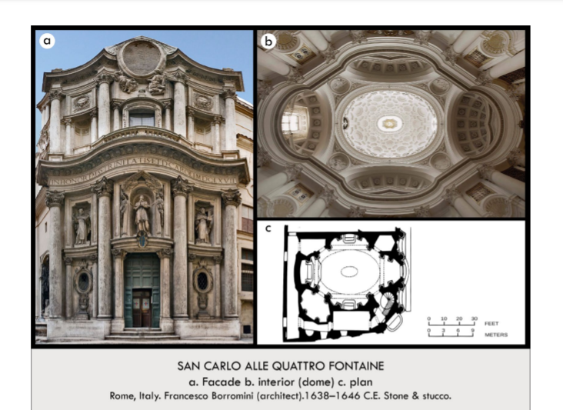

| **Form:** Utter baroque fantasia, curving balustrade, corinthian columns, very curved coffered ceilings, curving surfaces. Facade with 3 bays **Plan**: Two triangles (diamond) inscribed in an oval, Circles inscribed in triangles, Intersecting circles, No right angles—curves. Sophisticated inter connection of geometrical shapes, Musical and mathematical. stacking together three distinct units, undulating lower zone, Middle zone standard Greek cross plan, oval dome —The dome appears to be floating above the interior of the church because its springing point and light sources are concealed by the zone below.-- combination of precedent and novelty, complex interweaving rhythms.Bold illusionistic effects, achieved by calculated lighting, intensify the space.  **Function:** Dedicated to St. Charles Borromeo and the Holy Trinity (for the Trinitarians). Make a great church within a very small and cramped space  **Content:** The innovative facade—taller than the rest of the building-features an undulating, sculpture-filled screen punctuated with large columns and deep concave niches that create dramatic effects of light and shadow. The upper story balustrade is topped with a forward-leaning cartouche held aloft by floating angles. The monochromatic interior contains massive pairs of corinthian columns holding up an undulating enabling entablature supporting an oval dome filled with interlocking geometric coffers. The dome appears to shimmer and float due to windows placed in the lower coffers. Monochrome interior, shows a beautiful curative and sense of movement in the building **Facade**: Undulating waves, Upper part= concave bays-Sectioned entablature, Center = oval held by asymmetrically placed angels, upper facade completed only after Borromini's death. Lower stories = 2 outer concave bays and a convex center- United by continuous entablature, central niche above the portal. statue of St. Charles . sides are statues of the founders of the Trinitarian order, St. John of Matha and St. Felix of Valois **Dome:** Windows at the base add to ethereal effect (hagia sophia), coffering= circles with octagonal molding, unequal hexagons, and Greek crosses, Has window of real sunlight where an oculus might be series of oppositions, lower and upper levels, the center and the edges, tall columns and the smaller niches, Convex and concave, Paradox of imagination/ fantasy/ emotion vs. intellect (Adds to the mystical effect of the church, and describes the mysteriousness of religion, Impact of emotion when you’re there— you don't even realize how incredibly complicated it is) **Decorations:** Symmetrical, Many carvings (Borromini =stonecutter by trade), Cherubs, Light unifies the space, Perk of white interior  **Context:** Designed by the architects by the architect Francesco Borromini- his first independent commission. It is located on a piece of land at the intersection of two wide streets. One diagonally-cut corner site contains a fountain( one of four) that gives the church its name. Shows curves and playfulness. Characteristics of the **Baroque**: Undulating movements and sculptural effects. Eliminated the corner in architecture (almost all corners on this are soft. Borromini had full creative freedom. Rome, It was commissioned in 1634 and was built during 1638–46. except for the tall facade, which was added about 1677  Francesco Borromini Italian architect who was a chief formulator of Baroque architectural style.  **Compare:** Piazzi chapel.  **88**  Early Europe & Colonial Americas |
| --- |

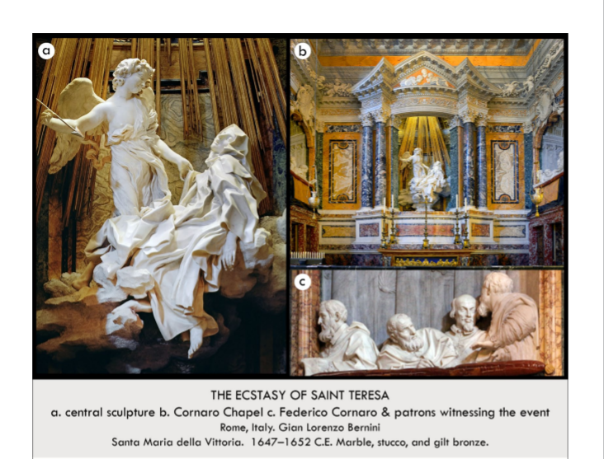

| **Form:** Marble sculpture, Dynamic, realistic, but not naturalistic figures, Flowing, rippling robes showing the outline of her body while simultaneously covering it. Movement in their clothing, facial expressions, and body language, St. Teresa's writhing body beneath the heavy cloth, She appears to have just recently collapsed, mouth open in awe, eyes half-lidded in wordless pleasure. Angel's clothing being whipped up by a perpetual wind. Expressive and emotional, not passive or calm; bears resemblance to Constanza bust and his David (see below). Media - White marble, carved out with a chisel. Genre - Kinetic art  **Function:** Created for the bernini for cardinal federico cornero in the Church of Saint mary of victory rome. Serve as a visual representation of the moment St. Teresa was awakened and brought to God, Physically, the central sculptural group in the chapel.  **Content:** The people who bought it are sculpted in opera boxes watching the scene of saint maria who wore visions of god's love and said that an angel stabbed her with a spear over and over again. A sculpture group depicting the Cornaro family, portrayed in marble as spectators in choice balcony seats,watching a theatrical performance of a mystical drama. The recently canonized Saint Teresa of Avila - a nun of the Carmelite Order - is shown in a moment described in her diary: After the death of her father she fell into a series of trances, saw visions and heard voices. Feeling a persistent pain, she attributed it to the fire tripped arrow of divine love that an angle thrust repeatedly into her heart. She described this experience as making her swoon in delightful anguish. Golden arrow pointing "at her heart", tilting downwards"Rays of sun" behind them; holy light of God. St. Teresa:, Accompanied by a "high ranking" angel floating with wings on his back, Her body is contorted in joy and pleasure, twisting feet and hands, Rays of sunlight in the background (gold), Rocks surrounding the base of the sculpture, supporting it and allowing it to buffer the main part, Expressive folds of clothing, which were not uncommon for his style (see below), A "fabulous illusion of architecture—a coffered barrel vault, doorway and columns"  **Context:** He designed the entire chapel, he created the sculptures, gold sun rays, a hole that was able to light the sculpt and then created the pediments. Shows the draw and elaborateness of the time. Bernini’s supreme handling of marbles is disabled by the multitude of textures carved from this single block of marble: feathery wings, smooth flesh, rough clods and gauzy material. Golden light from a hidden window above follows gold rays onto the group below.  —A quintessential example of Baroque theatrically and the unification of sculpture, architecture, precious materials and space.  **Compare:**  **89**  Early Europe & Colonial Americas |
| --- |

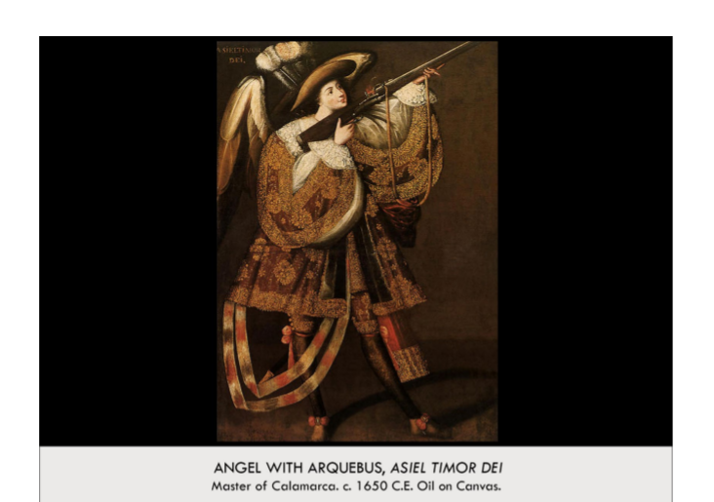

| **Form:**  Representing celestial, aristocratic and military beings all at once, these angles were created during the missionizing period.    **Function:**  Propaganda- you have to save their soles and if you cant you have to kill them, forceful conversion purposes  **Content:**  An angle of the catholic faith wielding the newest, deadliest weapon of the age, dressed in the finery of European and Incan aristocrats-is illustrated to aid in the termination of Pre-Hispanic religion and to enforce Catholicism. The armed angle is inscribed with Asial Timor Der Asiel, Fear of God. This androgynous figure, with its elongated body and dance-like stance - reflects a contemporary tast for Mannerism  **Context:**  When the new word was first being colonized. South American painting in a baroque and mannerist style. One of many similar images produced from the 17th century through the 19th century in the viceroyalty of Peru. looking at a catholic image from the new world. We do not know who painted it. The catholic counter Reformation Held a militaristic ideology that portrayed the Church as an army and angels as its soldiers. Representing celestial, aristocratic, and military beings all at once, these angels were created after the first missionizing period, as Christian missionary orders persistently sought to terminate the practice of pre-Hispanic religions and enforce Catholicism.  **Compare:**  **90**  Early Europe & Colonial Americas |
| --- |

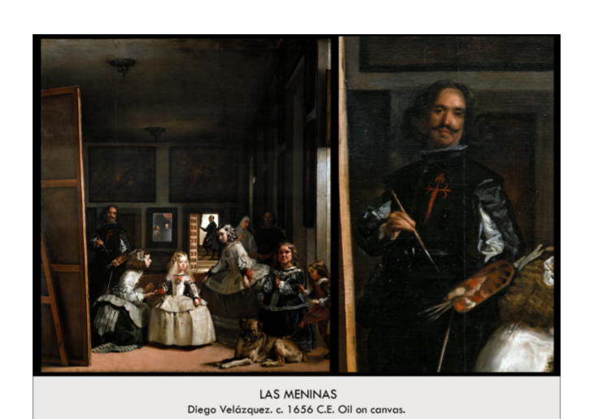

| **Form:** Oil paint on canvas. Very large painting. Took place in his studio, shows himself in the act of making the painting. Paints form the king's point of view. Shows an expert use of light on the people's bodies, and space in this painting. Not painting as a norther painters with individual brush strokes Uses very loose brushstrokes, but still comes together compositionally to create a clear, detailed, realistic image that also has a sense of life, up close it doesn't work but when you step back it works perfectly. 1656, Used to be housed in the royal palace(Royal Alcazar of Madrid), the king’s study Utilizes scientific, but also aerial perspective. Multiplication of the light sources  **Function:**Comision is for private study of kings place, to paint portraits of the royal family so they can use it to decorate their home. ( placed in the kings study) Velazquez gives us informal glimpse, something we, as commoners could never see, Made for the King and Queen to privately, demonstrates the art of painting by showing an artist at work, trying to give idea that artists were intellectuals  -a self portrait that shows status, he is seen in the same room with the royals, at the end of his life to become a gentleman, wanted to be a knight a the order of Santiago  **Content:** Marguerite, the princess on the main subject of the painting who is being intended to by her friends and servants getting her ready for the painting, you are looking at the back of the painting that you are looking at the front of. He is looking at the mirror and painting a picture of him painting. You are standing where the king and queen of Spain are standing and basically see their view. He paints himself as the biggest figure- takes a lot of guts. Utilizes Illusions of space, depth and perspective, Surface of his canvas is hidden to us,-The figures in the painting look at us in a very real way, the glances tell a story, set in his studio, he paints a pallet which is very mind-blowing because it is shown housing raw paint, the very stuff Velasquez actually created this work with, He was inducted into the Catholic organization the Order of Santiago posthumously by the king, so in the painting, after he died the insignia of the group was painted onto his figure, it is even rumored that the king painted it on himself, groups of two's all male/female pairs highlighting the princess, also use of groups of three on same horizontal plane  **Context:** Created a new way to paint a portrait in the time. A master class of what it is to create a painting. shows an entirely new perspective. Called the greatest painting of the world. Shows a completely different way to do art/portraits. King saw exactly what he was when he had his portrait done that day. Painted after he was knighted by the king. At this time painters were considered as nobles and where given prestige during the time, shows Velazquez genius and skill. Not a typical portrait, which demonstrated ethereal perfection, wealth, and command, this scene is more chaotic/informal, making commentary on the false nature of portraiture of royalty  -Combines genre scene with royal portrait  **Compare:** Paintings of Ovid's The Metamorphosis that hang in the background, both stories of gods wrestling with mortals, very applicable to the themes of Las Meninas  **91**  Early Europe & Colonial Americas |
| --- |

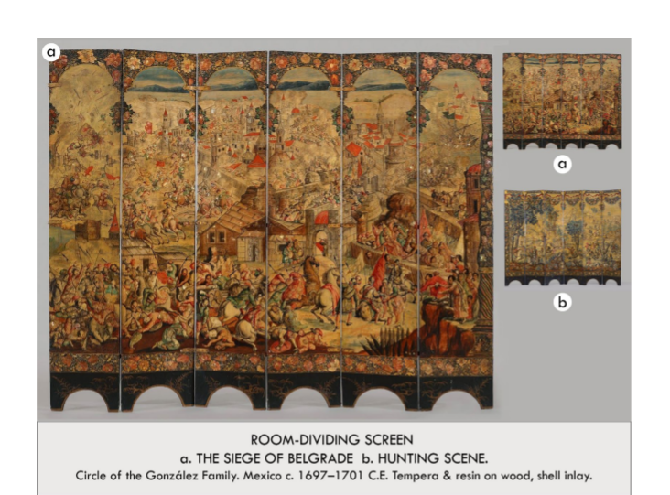

| **Form:** Two sided screen made of tempera paint on wood. It folds to create a screen. Only known example of a biombos- a room dividing screen common in Asia- that is illustrated with Enconchados-a combination of oil painting and Japanese lacquer often containing other-of-pearl laid out where needed in the composition. Originally included 6 additional panels  **Function:** Use in the Viceregal palace in Mexico city. decoration/as a screen  **Content:** Both sides illustrate scenes of Habsburg Power: WAR SCENE-depicts a contemporary Battle of the Great Turkish war of the 1680’s Fought between the Ottoman Turks and the Hapsbourg Royal family. HUNTING SCENE: depicts Hapsbourg Royal on a game hunt-a royal pastime. Siege on one side, hunting scene on the other o The scene from the Great Turkish War (1683–99) after a Dutch print on its front side was an ideal propagandistic backdrop of Habsburg power for the reception of the viceroy’s official international visitors. The decorative hunting scene on the reverse, also based on a European print source (see illustration), was better suited for a more intimate room like the estrado  **Context:** Commissioned by José Sarmiento de Valladares, viceroy of New Spain, for use in the Viceregal palace in Mexico city. The only known work to combine the two elite Mexican genres of biombos (folding screens) and tableros de concha nácar y pintura (shell-inlay paintings, later known as enconchados, it was most likely displayed in Mexico’s viceregal palace, where it would have divided a ceremonial state room from a more intimate sitting room  **Compare:**  **94**  Early Europe & Colonial Americas |
| --- |

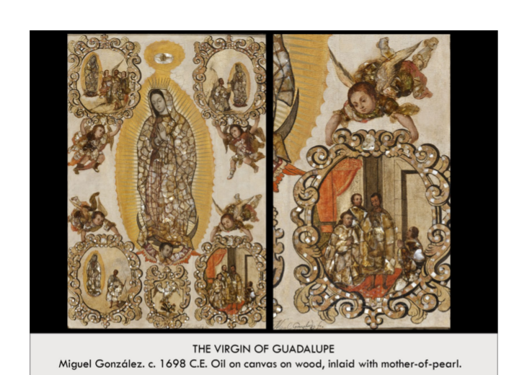

| **Form:** An Enconchados painting (paint with mother-of pearl) depicting one of the most common and revered symbols in Mexico: the virgin of Guadelupe, Patroness of new Spain. portrays the Virgin as she appears on the *tilma*: in three-quarter view, crowned, hands clasped, eyes cast downwards, encased in light, and standing on a crescent moon that an angel supports  **Function:** Decoration / a religious parenting  **Content:** In Guadalupe images Mary stands on a crescent moon, surrounded by sun rays, clouds behind her (Revelations 12:1 “ A women clothed with the sun, with the Moon under her feet and a crown of 12 stars on her bed…”) Four accompanying scenes depict an event in which Mary appears to Native Americans on a hill called Tepeyac as a shine sacred to a Pre-Colombian Goddess. Mary orders a native American covert - Juan Diego -to tell the local Archbishop To build a sanctuary on the site. Mary Makes the hilltop flower, Diego brings the Flower to the archbishop, and the Virgin appears on a cloth carried by Diego. In the four corners of the painting (below) we see four framed scenes carried by angels. These represent different moments in the story of the miracle. In the upper left, Juan Diego is led to the Virgin Mary by angels. In the upper right, Juan Diego has a vision of the Virgin Mary at the Hill of Tepeyac; in the lower left, Juan Diego takes leave of the Virgin Mary with a full cloak, and in the lower right Juan Diego reveals the miraculous image on his cloak to the bishop and others. pieces of mother-of-pearl shell to form most of the Virgin Mary’s clothing (it even decorates the bodies of the angels and the frames they support). The iridescent shell would reflect shimmering candlelight to emphasize the sacredness and importance of the Virgin Mary. Above the Virgin of Guadalupe is the dove representing the Holy Spirit in a golden cloud, and below an eagle perches on a cactus.  **Context:** A symbol of Mexico- an eagle perched on a cactus. By the seventeenth century, when creoles were looking for ways to emphasize New Spain’s greatness and uniqueness, the symbol of the eagle on the cactus once again became popular as a symbol for Mexico City. Its inclusion here. *Enconchado* artworks were popular in seventeenth-century Mexico. The shell is placed into the painting like a mosaic, then covered with glazes. Shell-working had been an important art form among some Mesoamerican peoples  **Compare:**  **95**  Early Europe & Colonial Americas |
| --- |

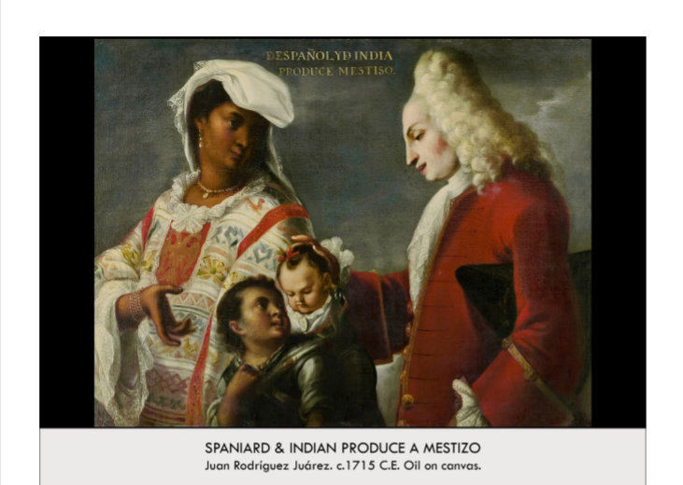

| **Form:** One panel from the first known series of Casa Paintings-images made as illustrations of different races and their places within a 16-step caste system with Europeans at the top.  **Function:** Propaganda in support of these cultural practices. Discourage race mixing, influences that if mixed with European blood one is superior, the family will live in harmony, and “perfection” as seen in the work, casta paintings: reflect increasing social anxieties about inter-ethnic mixing. it is possible that elites (pure blood) found the dilution of pure-bloodedness alarming (they were the ones that commissioned the paintings)  **Content:**  simple composition (arrangement of visual elements in a picture), Spanish father and Indigenous mother with their son, mother and father surrounding two children: a young boy is carrying the couples baby, Modeled off the Holy Family: Virgin Mary, Saint Joseph, and Christ as a child (interpretation)  **The indigenous mother**: dressed in *huipil* (traditional indigenous garment) lace sleeves, and expensive jewelry, turns and looks at husbands as she gestures towards the child.The native woman is shown with Europeanized features and with respect indicating the harmony of the mixed races.  **husband (Spaniard father)**: wears French-style European clothing, powdered wig, gazes down at the children, hand resting on the child’s back or wife’s arm the young servant looks upwards to the father (not his father): allude to his greatness, The family appears calm, harmonious, loving  **Context:** Their images were often sent abroad. Created during the 18th century during colonization of the new world. *mestizo: (a person of a European and indigenous parent)* a Spanish man and an elite Indigenous woman. This painting (the first of the series as many like this were= indigenous mother + Spaniard father)belongs to a larger series of works that document the intermix racing of the Spaniards, indigenous, Africans, and mixed population (e.i. mestizo). Casta painting*s*: focus on bad living conditions for families that become more and more racially mixed, 2nd half of 18th century. As the series progresses in casta paintings (different races mixing, as families become more racially mixed) = displayed in tattered, torn, and unglamorous surroundings/ bad family dynamic after the Spaniard and indigenous family: race mixing is bad, seen as lower if you do not have European descent  **Compare:**  **97**  Early Europe & Colonial Americas |
| --- |

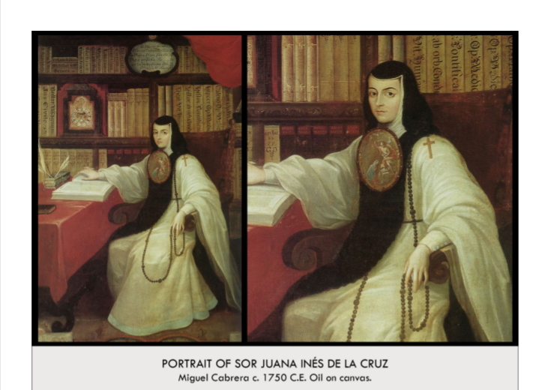

| **Form:** Oil on canvas. Created by Miguel Cabrera. Patron: Sor Juana Ines De la Cruz Location: Latin America Date: 1750 Style: Portraiture Movement: Art of New Spain = Mexico (Enlightenment/Neoclassical)  **Function:**A memorial portrait created 55 years after the death of Sor Juana Ines de la Cruz, a nun of the religious order of the Hermits of St. Jerome in Mexico City.  **Content:** She is shown surrounded by symbols of her faith and learning wearing an Escudo- a framed painting worn below the neck in colonial Spanish painting. Realistic, Similar to other portraits of the time, Red curtains behind her were common in elite portraits (higher status). Religious garments = convey the deep connection she had with her faith. Books = communicate her love for learning. Portrait of Sor Juana, a catholic nun and sister of the jeronimite order in New Spain. Portrayed as a hero (Neoclassical). Intellectual rather than traditional  **Context:** Sor Juana was a revered figure who published many worlds, maintained a great library, created educational opportunities for girls in a male-dominated world, and was a painter. Instead of marrying, she decided to pursue her intellectual passion in a Carmelite convent before converting to the Jeroimite order (more freedoms). Despite being a nun, she defended her rights as a woman.The image is derived from a now-lost self portrait. Femisnist culture was natural in Mexican convents where privileged nuns lived in comfort with servants and households. Neoclassical Work Miguel Cabrera Portrayed the nun in a way that gave tribute to her religious AND intellectual purposes. Painted after Sor Juana's death (probably based off of other portraits)  **Compare:**  **99**  Late Europe & Americas |
| --- |

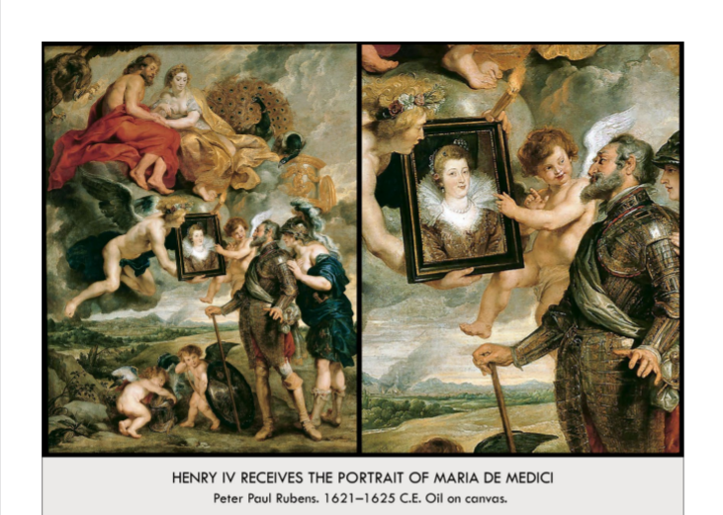

| **Form:** This painting is part of a set. Oil on canvas. Composition strong diagonal, baroque painting with renaissance touches. Painting with naturalism. Marie and Cherub are the only 2 looking out at the viewer: establishing the central authority and future importance of Marie and her progeny for France. Strong vertical axis running through the work from Juno/Hera (top) through Marie de'Medici shows the maternal, fertile connection between ideal wives and mothers, as Rubens depicted it.  **Function:** Propaganda and flattery. Showing her as a goddess in a way. glorifying and justifying the life and accomplishments of Marie de'Medici, Queen and Regent of France. To depict Marie de'Medici's life in 24 defining paintings. To compare Marie de'Medici's right to rule, wisdom, and beauty to the ancient mythological gods (ideals at the time of the Baroque era) To establish Marie's power and her lasting legacy in France.The Presentation of the Portrait  **Content:** Winged Gods of Marriage (Hymen, left) and of Love (Amor/Cupid, right) present a portrait of Marie de'Medici to the enamored King Henry IV of Navarre. Hymen holds a flaming torch in his left hand: symbolizes the passion of love. Cupid gestures at Marie de'Medici and praises her beauty/worth. Smitten Henry IV looks on in sheer adoration and delight. Jupiter and Juno (or Zeus and Hera) look down from above in approval. Flanked by their animal symbols: Eagle with a Thunderbolt (Jupiter) & Peacock (Juno). Personification of France stands behind Henry, encouraging him to marry for political reasons, She looks on approvingly at his adoration of Marie. Lady France wears a plumed helmet, blue robe with an embroidered fleur-de-lys. Lady France whispers in King Henry's ear Tells him to ignore his battles and marry Marie as a smart political move. Domestic matters are equally as important as military ones to preserving the monarchy. Henry obliges; his helmet and sword are being toyed with by 2 cherubs in the foreground (putti)  **Context:** Commissioned by Marie de medici cycle. Each of the paintings the physical political story is going on also well that the mythology all well. Combines reality and mythology. Paintings and images of royalty. Painted by the Flemish artist Paul RUbens who was very famous and rich at the time. King and Queen's faces, all hands, and several details in the cycle were painted by Rubens; the rest he designed, but had members of his workshop paint for him in his style.6th painting in a series of 24 works on the life of Marie de'Medici, the orphaned daughter of the Duke of Tuscany.  **Compare:** Mancare and his queen -stone statues (egypt)  **86**  Early Europe & Colonial Americas |
| --- |

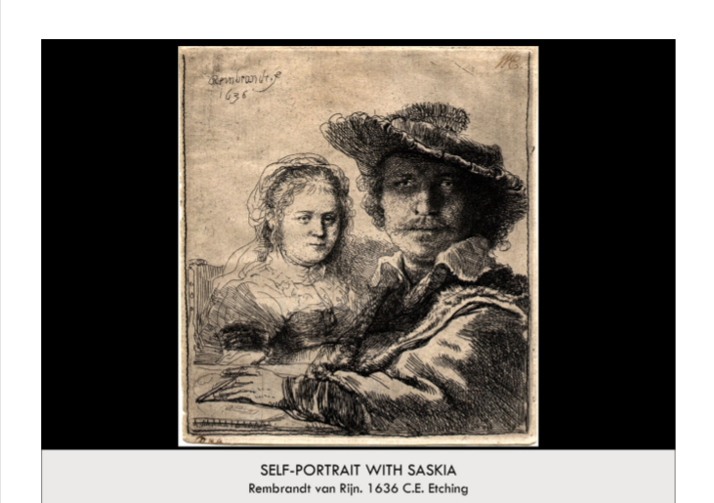

| **Form:** An etching on brass, a print- ink pulled out of the groves. Rembrandt used a copper plate, eroded by acid, to create this work, The Etching plate is deeper for Rembrandt than Saskia. Shows him as more important, but also closer to the viewer. He first etched in Saskia to help create the illusion that she is behind Rembrandt. This was likely etched in a mirror  **Function:**Created for himself to celebrate his young wife and his marriage. Private artwork, comments on the nature of their relationship. We are getting a view into a private moment as if we have literally interrupted it  **Content:** Shows him who is dressed up nicely and his wife. Obviously, this is a marriage portrait- depicts a young Rembrandt with his wife Saskia, This is the only etched portrait of the two together. Rembrandt rarely depicted himself as the contemporary Gentleman—Against the style of time, We are present in the scene. This etching also marks the first time Rembrandt depicted himself as an artist in the work  **Context:** created by Rembrandt. Depicts a thirty year old Rembrandt and his wife Saskia, two years after they were married. Rembrandt is one of the most prolific etchers of his time with nearly 300 to his name, many of his early etchings have the immediacy and spontaneity of a rapid sketch. Highly experimental artist, Used a soft ground to allow him to draw freely on the plate. He is also well known for his portraits, His style changed greatly over his lifetime, With his early works we see a much more extensive use of Chiaroscuro, His later works show his evolved confidence as an artist. With the Self-Portrait with two circles we see him definitely claiming his genius. We also see his comparing of himself to the likes of Giotto with the two circles in the background  **Compare:** Durer self portraits  **87**  Early Europe & Colonial Americas |
| --- |

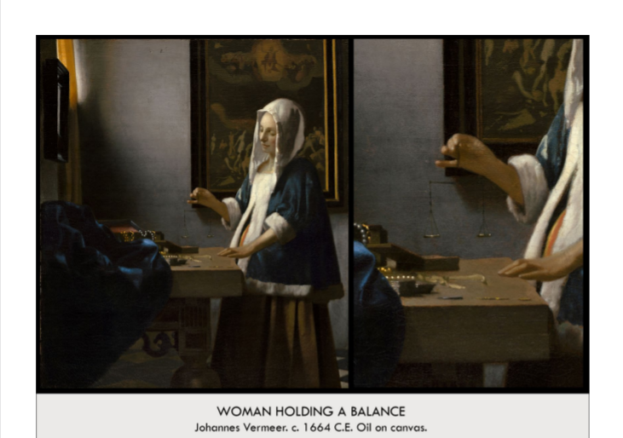

| **Form:** Oil painting on canvas. 1´3¨ x 1´2¨ Very material and naturalistic and in our world. pinky is the vanishing point. the center of the painting is the center of the balance, compositional control in the way that color is handled. gold from curtain on the inner painting frame and the pearls and dress, soft swirled painting style —common in baroque. generally muted colors save his favorite blue and gold. Baroque:great drama, rich color, and intense light and dark shadows. most dramatic point, the moment when the action was occurring. Baroque art was meant to evoke emotion and passion instead of the calm rationality that had been prized during the Renaissance." **Vermeer uses:** light, shadows, vibrant colors, emotion thought, diagonals, attention to details  **Function:** A genre scene complete with symbolism. wealth and piety / spirituality. To show what people in 17th C Holland were like  **Content:** Intruding on her and her daily life.she’s part of the upper MERCHANT class in Holland during the 17th C. Typical cap made of linen worn by women at home, fur trimmed jacket meaning it's cold out / in. stands in front of the table. on the wall opposite her is a window LETTING LIGHT IN. golden curtains, also a mirror, right hand has a very fine balance, nothing on the balance-as if she is waiting for the balance to come to a rest. on the table in front of her there are a number of boxes. Woman is holding a scale- measuring her jewelry to determine her value-material wealth. Has a serine and focused expression, wearing a very expensive garment which is lined with fur and a light vale. The light just coming through the window, she is a symbol of worldly things-jewelry and wealth. Behind her head is a painting of the last judgment - Christ deciding whether people will go to heaven and hell. Christ is also weighting - people's souls. Contrasting element- don't just focus on just eathly aspects and remember what will happen to you after - don't be greedy ….. Vanitause - reminding you of your death. her head divides the blessed from the damned. Light also plays a huge part in this, her front is illuminated = the side of the blessed. her back is dark = damned. The light also creates motion, bringing to life this idea that she is waiting for the balance to become still —aka the idea of time and change. very real and natural at the same time bc this is a snapshot so it is frozen and quiet  **Context:** Vermeer Unknown for the past 300 years. He was known as the painter of light. Quiet independent master, sold his paintings except for this. Painted during the 17th century. One of the greatest paintings. From baroque in northern Europe. Specialized in : main subject going through normal activities/doing something in rooms . Possibly used something to see further detail. Duch baroque.  **Compare:** Qunitian masstines money launder and his wife - she is ignoring the bible by looking at his coins  **92**  Early Europe & Colonial Americas |
| --- |

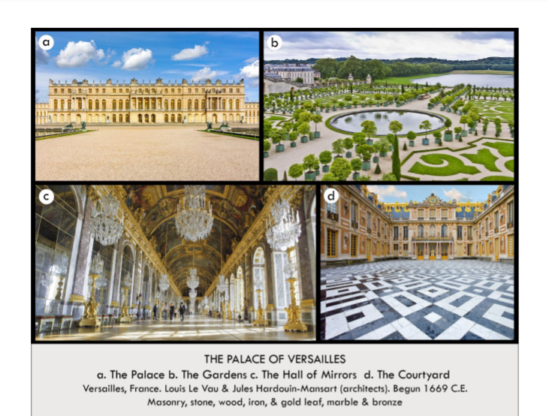

| **Form:** It was far from Paris and on the outskirts. Has a baroque style and combination or painting, statue, and architecture. Stone, marble, glass, gold, silver, wood, gardens, 700 rooms, 2153 windows, 67,000 m^2 of floor space, 2000 acres of gardens  **Function:**Palace of the sun king. Residence of king and seat of its government of its king. Shows Louis XIV and Frances wealth and power as the king of France. To emphasize and demonstrate Louis XIV's Importance. To host parties and military agreements. To compare Louis XIV's competence and wisdom with that of the ancient Greeks and Romans, especially Apollo, the Sun God.Demonstrated the shift in the French government's power from the Noble families (aristocracy) to the King, Louis XIV  **Content:** Entire place centers around bedroom ov louis XIV which faced the rising sun to represent him as the sun king. architecture is understated on the outside- not much curvative Extremely detailed, ornate interior. Top architects and decorators designed wall paintings, beds, doorknobs in French Baroque style.D) Gardens are fully manicured and controlled and the other part is free and wild nature. Tile work, use of color and shapes. Baroque decoration. Visible from Hall of Mirrors: central axis lined with trees, terraces, pools, and lakes. Designed by André le Nôtre, who transformed a forest into the park/gardens, Formal gardens serve as a transition from the ordered, man-made palace to the natural gardens. Manicured shrubs, highly designed space. Changes depending on time of day, season, and location: it's an experience C) Hall of mirrors barrel vaulted and painted and creates a frickling fantasy interior.was the highlight of the palace. Very long halla( mirrors where very expensive at the time) D) Garden complex out the back, fountains and pools, they came on when he was walking by. Originally had furniture: gold and silver chairs, bedazzled trees, Walls inlaid with mirrors. Mirrors create illusion, the hallmark of the Baroque style, Used for Louis XIV's many festivals  **Context:** They bankrobber France for the creation of this palace. Other palaces are designed after. It started small and then expanded. It hosted thousands of nobles and their servants. He was created the first modernized centralized government. A time when france was the center of the world at the time. Louis was a renaissance man who was called the sun king modeled after apollo. (thought of himself as almost a god on earth) he ruled for about 70 years and was a perfect absolute monarch.  **Compare:** forbidden city= clustered palace way from community in the ming dynasty.  **93**  Early Europe & Colonial Americas |
| --- |

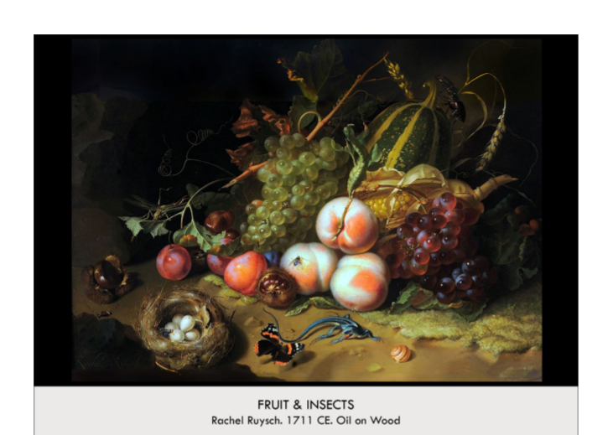

| **Form:** Oil on wood. still life painting. by Rachel Roch who was the daughter of a botanist. She includes living elements in her paintings  **Function:** For decoration. For herself. Painted for her Cosimo III = sign of friendship and common wealthy status, Sold for double that Rembrandt's paintings sold for. Painting for a widening merchant class. Intricate and formulaic approach that dominated the late Renaissance- Less complex but more realistic  **Content:** An idealized still life showing all four seasons of fruit at the same time. Possessing elegant skill and technique (element of sensitivity) She used bold and dynamic colors and textures-Parallel to the growth of the Dutch industry and science of botany- Flowers became newly appreciated simply for their beauty and fragrance—Desirable status symbols for the wealthy. However this work speaks to fruits and insects, Season = Autumn, Subject = fruits, vegetables, harvest, and insects. Composite of the studies (combined into this composition) Grapes = blood of Christ, Animals = naturalism, Corn, Squash, Chestnuts, Also Wheat = Eucharist (christian symbolic value). Attention to detail (particularly leaves and flowers). Less symmetrical and much more lively, Curves (a sense of movement) Less formalized and orderly, Possessed energy and creativity. A sense of illusion and realism (the painting seems real). Story (a world of its own)--Butterfly that is about to land but perhaps has second thought because there is a salamander or a small lizard  . Talkies about life and death. Has a conceptual style.  **Context:** The time painters started to paint for themselves, done necessarily to make paintings on commissions. The painters have to compete with each other= Duch painters at the time. She paints interesting still lifes. Still life paintings were increasing in the netherlands. This is the dutch Baroque where middle class families would buy still life paintings. Renaissance art was at its peak––> artists began to challenge the societal norms (accepted artistic styles and elements of the time). Artists reinvented the way art was portrayed ––> led to a new form of art- Vibrant colors (red and green), Uncommon subjects. 1648 = Netherlands became independent from Spain (economic prosperity)= Flourishing international trade = newly affluent middle class. Wealthy merchants created a new kind of patronage and art market = producing directly for buyers (rather than work commissioned by the church). Historical, mythological, or religious paintings were no longer desired = buyers wanted portraits, still-life, landscapes, and paintings of everyday life- Artworks that would reflect their success Rachel Ruysch became known as one of the greatest floral painters of her time. Grew up in Amsterdam into a wealthy family of Dutch artists, architects, and scientists, First successful female artist during the Baroque  **Compare:**  **96**  Early Europe & Colonial Americas |
| --- |

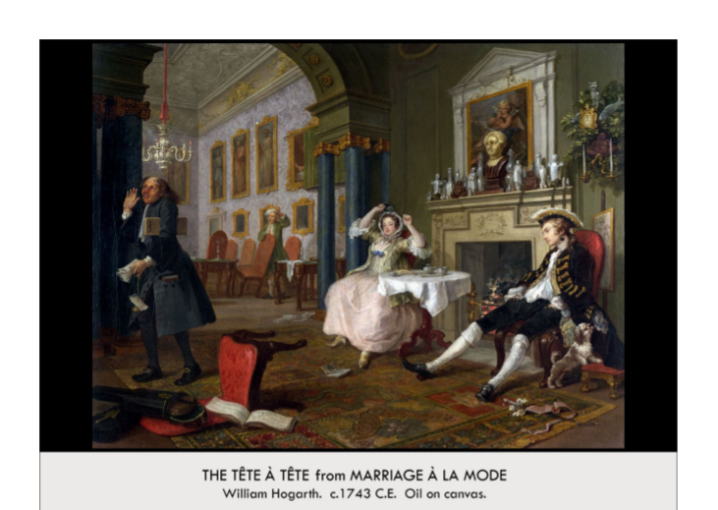

| **Form:** Oil on Canvas, Composition: A few objects in the foreground, but overall fairly empty. All central figures in the middle ground (the obvious "focal ground" of the painting), The background consists mostly of a separate room, architectural features, and paintings. One clear area of emphasis is the cluttered mantlepiece, positioned strategically between (and a little above) the couple.Verticals lines are found the in the edges of the paintings and in the columns.Curved lines are seen most prominently in the arch between rooms.  **Function:** To make fun of the work, a satirical artist= to make fun of the ritch and show how stupid. ( shows that rich people are no better then anyone else and that they can be worse with their decidence) To appeal to the middle class. To draw distinctions between the inherited ideals of the aristocrats of the 18th century and the actual actions/lifestyles they lived by. To criticize conspicuous consumption  **Content:** The moring after the two people have been parting separately since they dont love each other. She has a smug expression and the lawyer who is walking out of the screen because he has given up. The husband has been out with other women all night. Servant in the back is yawning. The Tête à Tête translates to head to head or face to face -- also a heart-to-heart or one-on-one.This second painting of the set shows the young couple just after their forced marriage and things are *not* looking good. The scene is set in a lavishly decorated room with plenty of art pieces, a fancy carpet, gold-outlined architecture, and a chandelier. The husband, Viscount Squanderfield is seen slouching in a chair on the right. He has a dot on his neck that would have been recognizable to the people of the day as the mark of syphilis likely just returned from a night of womanizing. A dog (a sign of fidelity in the Renaissance) sniffs at a bonnet in his pocket, insinuating that he's been intimate with another woman. The wife, Viscountess Squanderfield, sits on the left looking quite ruffled. The top of her bodice is undone, insinuating that she's been intimate with another man.The account stands perplexed on the middle ground of the left side of the painting. He looks completely fed up with the couple and their lack of care for their finances. In the room, there are several important items: the instrument on the floor that's fallen out of its case (the chair it was on has also fallen!), the paintings of saints in the room left background of the painting, the classical sculpture with a broken nose on the mantlepiece, symbolizes the couple's lack of interest in classical ideals and values as well as impotence. the painting of cupid in ruins  **Context:** Created during the Rococo period. By William Hogarth who was considered the first great english painter of the time and was known for his satire and story works. ( series shows that all of these peoples lives are corrupted and they are all selfish). Satirical art became a big part and influences in the 18th century. Showing the satire of the times and before people wouldn't even think of doing that to the nobles and royalty. The idea that you can make any art you want started in these times. The Tête à Tête is the **second** work in a set of **six** distinct (but interrelated) paintings that together, in a chronological order, form a coherent, meaningful, funny narrative. Altogether this work is known as "Marriage à la Mode." The general plot revolves around the monetarily-motivated marriage of the daughter of a merchant to the son of a well-known family. It tells their tale from the day their marriage contract is drawn up to the day Viscountess Squanderfield dies. Ultimately, it aims to depict the (literally) fatal consequences of marriages not based on love.Thus, the aristocracy lost some power to the merchant class. William Hogarth capitalized upon this truth and created Marriage à la Mode directly for the enjoyment and consumption of the new middle class.  **Compare:**  **98**  Early Europe & Colonial Americas |
| --- |

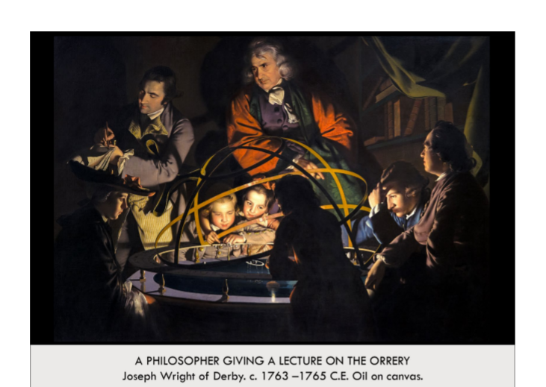

| **Form:** Shows realism in the faces and scene. Oil painting on canvas. Painting of strong contrast cursuri, contrast between that light and dark. Painted by Joseph Wright of Derby, The style is an English taste for the natural, Strong uses of color and lighting: Lighting and shadow used to promote realism and illuminate faces and expressions, Heavy contrast between general darkness **( Chiaroscuro)** of the painting and the light coming from the central orrery, Red coat of the one man suggests influence, as he is the lecturer.  **Function:** Illustration of scientific ideas( of learning). - his subject is learning itself - show you the role of teaching and educating yourself. Showcase the scientific advancements of the Enlightenment, such as the orrery that is central in this painting, Also meant to illustrate the general feeling of curiosity and thirst for rational knowledge of the Enlightenment. The work also shows that women and children were getting involved in the movement, as they are also surrounding the orrery  **Content:** Faces are unbelievably realistic. Shows a mastery of light and dark. Looking at a family having a privet lesson with a philosophy , and they have gone to an orrery= place of scientific study. Middle class and upper middle class bettering themselves through education. The guise of the philosopher is Isaac newton. Learning is not just for the old put is for the young, children is gathered around the planetary models. There is a lot of color. Scientists, note-taker, and kids surrounding a central orrery—An orrery is a mechanical model of the solar system, depicting the orbits and relative relationships of the planets and sun— Each person depicted is meant to be a specific, real person, but we do not know who they are, Strong internal light source representing the sun, also symbolizing the Enlightenment and the new search for reason and rational thinking, Painting also features women and children gathered around the orrery- suggest that these groups were also being given these opportunities for rational learning and higher education  **Context:** He is the only painting who shows people learning and advocated for the general learning of everyone, He painted about science and New ideas and technology. He was a painter during the enlightenment in the industrial revolution, which was when the idea that everyone should be educated and was not limited to only the rich. The age of enlightenment- you bettered yourself by character and you educated yourself. Joseph Wright of Derby actually became the unofficial artist of the Enlightenment  **Compare:** caravaggio - in its form( the light and dark), School of Athens  **100**  Late Europe & Americas |
| --- |

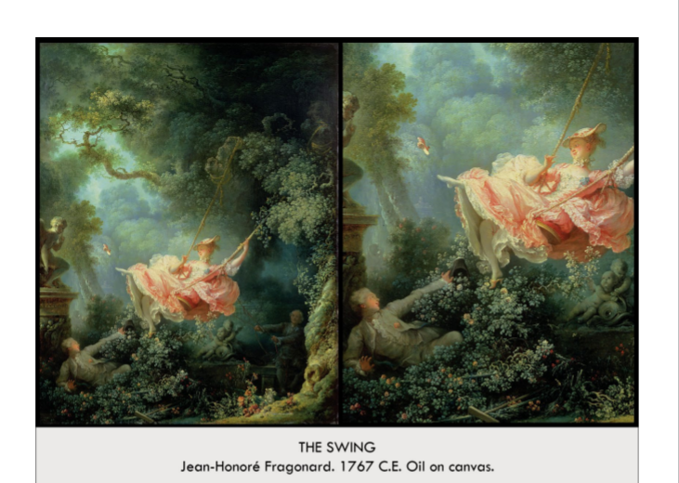

| **Form:**  Oil on canvas, small in size. Shows a very beautiful and fantastical image of light.  **Function:**  Decorate a Rococo design and to please a rich women, beauty and decoration  **Content:**  Aristocrats in a garden. The women is depicted swinging, playing with her lover and she is kicking her shoes off while he is looking up her skirt. Shows an impossibly beautiful beautiful and fantastical. She is being pushed by her attendant. Statue of a Cupid on the far left whispering. A small dog in the lower right barking at the girl on the swing. — demonstrates all the themes of Rococo  **Context:**  He was a young contemporary. Decondant. In is a Fete Glant style. Shows an absolute rococo style, doesn't show any religion- the times where drastically shifting. 1766: People of France were living better than population, Wealthy and lavish living, Women were major patrons of the arts, Art was seen as a wealthy escape from issues that France was facing, Art became exclusive to the rich, Art served as an attractive way for nobles to express themselves  **Compare:**  **101**  Late Europe & Americas |
| --- |

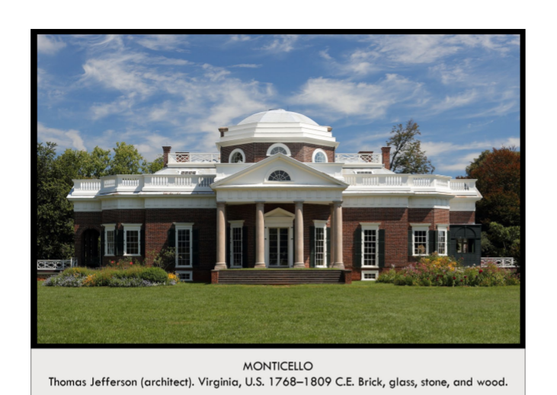

| **Form:** The form was largely based off the Pantheon. Located in Virginia. Marble Greek looking portico goes into a crucifix-like building, There is a dome in the middle (closer to the entrance), but it is not massive, There is marble fencing around the roof → assuming that it goes all the way around, Long, rectangular windows are on the walls, Everything is symmetrical around the central axis line of the door (vertical axis)  **Function:**The chief building on top of Jeffersons Plantation. The building is meant to live in. By helping to introduce classical architecture to the United States, Jefferson intended to reinforce the ideals behind the classical past: democracy, education, rationality, civic responsibility  **Content:** Monticello means little mountain in italian. Brick buildings with stucco made to look like marble, it show symmetry, has french doors and windows. A large balustrade hides the second floor, inspired by Andrea Palabdio, has an octagonal dome, very narrow spiral stair casses and beds are in between the walls and connors. Took inspiration from Classical and Neoclassical buildings in France when he was ambassador. Remodeled the original two-story pavilion based on the Hôtel de Salm in Paris(symmetrical single-story brick home under an austere Doric entablature)  West garden facade: two-column deep extended portico contains Doric columns that support a triangular pediment that is decorated by a semicircular window, balustrade (the fence thing on the roof) that circles the roofline provides a powerful sense of horizontality, Classical European Structure = **basilica plan,** Colonnades, Pediment, Persian windows, Dome, Transept = intersects like gothic church, Steps = ancient Etruscan temples, Gardens = French imitation  **Context:** Jefferson got his ideas for architecture in France form the neoclassicism style of architecture, Studied at William and Mary → was interested in the campus’s architecture, But he was never formally trained as an artist. Jefferson hated Britain, so he tried to stay as far away from British architecture as possible, Studied at  **Compare:** PantheonInspired, United states Capitol (white house)  **102**  Late Europe & Americas |
| --- |

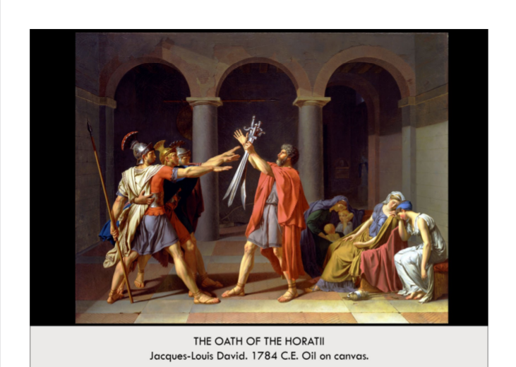

| **Form:**  Very large painting, shows a style of naturalism, artistic space is very ordered and neet. Neoclassical, Simplistic and Symbolic, Rejection of Rococo, Organized and structured. Male Figures = constructed with geometric shapes, Female Figure = organic/realistic shapes  **Function:**  Showing a history painting with actual examples from ancient times, public propaganda-meant to be seen by everyone.  **Content:**  One point perspective, in an arcade with doric order columns, left are three sons swearing an oath to their father-they are stiff, and angular- men are doing their duty. and on the right women. Story of Haratti brothers in rome and the two city states go to war so they chose 3 champions for each city state and these three are swearing to fight for Rome, and one women on the right is engaged or married to one of the brothers. Shows all the characters are idealized figures.  **Context:** made when his was studying in rome, shows all you patriotic duty. Shows the painting style of Neoclassicism=which is a classical revival, basically the exact opposite of the Rococo.  Legend of Horatti  Conflict between Rome and city of Alba, Instead of declaring war, they sent 3 representatives to settle dispute, sent 3 brothers of the Horatti. Typical for battles to be won as men remain standing, Held moral value in Roman culture- Sacrifice for the defense of your city is a noble case  Time of Painting  France was on the verge of its Revolution and the end of the monarchy, David picked up on the independent ideas resurfacing all over the world (revolutionary thinking)  **Compare:**  **103**  Late Europe & Americas |
| --- |

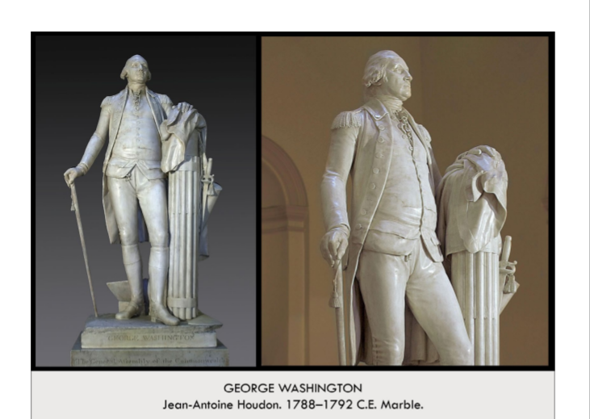

| **Form:** Made of Marple and neoclassical- nothing decadent about it. Neoclassicism, White marble, Contraposto, Symbolic details, Washington is seen wearing street clothing (fatherly expression), Symbolized power and authority as he holds his sword. not having the sword in hand = given up his military and presidential careers  **Function:**Made form the richmond state capitol. To portray the first president of the United States to the public.  **Content:** A statue of George washington, dressed as an 18th century gentleman, has the apollets on his soldering-shows milia=tary accomplishments, shows that sword to the side, a missing button on his jacket, his stomach is punching through his vest a little. It is mostly natural-shows a double chin, has the bagged an sincinatise- ancient roman farmer who became a warrior fir the cause. A plow symbolizing that our leaders where regular people. Leaning on a facies with 13 rods(13 states) He is holding a cane.  **Context:** Made by a French sculpture because there really were no artists in America- they did not have the time/privilege. Was a general who fought in the revolutionary war very well. This is a grand manner portrait statue in the style of Johuwa reynolds. Made after the American Revolution, At this time it was popular to commission the depiction of war heroes  Washington;s depiction was inspired by his choice to retire from his military position and precedency in order to pursue farming instead and allow his country to develop  Statue ordered = Virginia Governor  No practiced American sculptors  French people idealized the fore-fathers of America  **Compare:**  **104**  Late Europe & Americas |
| --- |

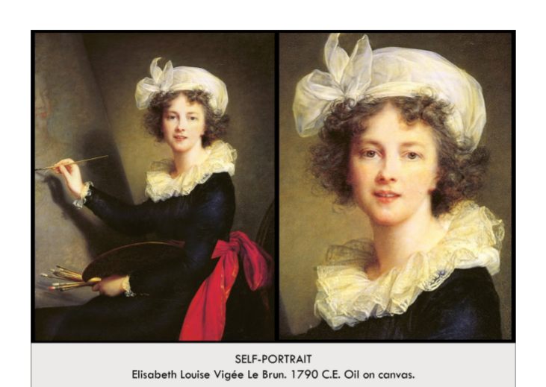

| **Form:**  Paints in the natural manor, moves away from the Baroque fantasy and shows naturalism. Return to the more naturalistic ideals that appeared in the Renaissance. Elisabeth is shown in a natural active position  **Function:**  As an occupational painting-to show possible clients her skills. Self Portrait  **Content:** Paints in a realistic style. Shows an image of herself painting the queen to show her accomplishments.. Contains Elisabeth Louise Vigee Le Brun who painted herself, She is wearing a traditional black dress with a very bright red sash, She is painting in the self-portrait= This portrait is probably of Marie Antoinette. This painting shows off the intelligence, freedom, and greatness of this female artist who was revolutionary for the time  **Context:** In the late 18the century. She was trained by her father, one of first women admitted into the art school ( french academy of painting and sculpture) in Paris. She had to flee to escape during the French revolution. She was the portartist to the queen Mari Antwinet. Had much accomplishments, had large talent at a very young age, and would create wonderful works at the age of 14. Not many female artists during this time, Le Brun worked for the crown of France specifically for Marie Antoinette, This was around the French Revolution so as a painter for the crown she was forced to leave France, Due to her work, Le Brun became very rich for her very detailed and beautiful depictions of the royal family, There was an emphasis on color and beauty in this time period and that is what she depicted, Themes: Independence, Beauty, Women, Intelligence, Work  **Compare:**  Self portraits: artemisia, Durr, rembrandt.  **105**  Late Europe & Americas |
| --- |